

**Help us help the Animals**

**Support our Fundraising for SPCA Cupcake Day**

**Monday 14th August from 10.30 a.m. at Clevedon Office**

**Also Barfoot & Thompson Clevedon is a drop off point for pet supplies for 9 Lives Pet Orphanage and Lonely Miaow Association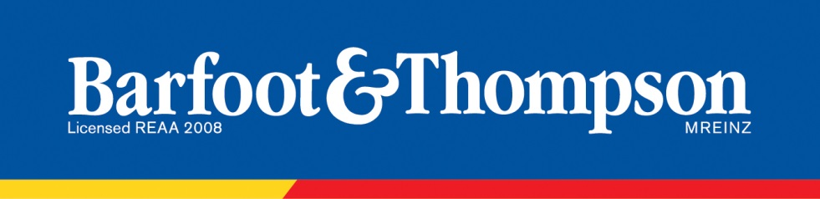https://spcacupcakeday.gofundraise.co.nz/page/JoanneMacLean**